Stanislaus Heberle
Birth: | Nov. 11, 1826
Death: | Aug. 29, 1903
Stanislaus Heberle is a descendant of the Heberle's from Rottenburg am Neckar Heberles in Germany. He arrived in New York in 1851 and settled in Henderson, Sibley Co., Minn. He was the eldest of eight children. He was a wagonmaker in Henderson. His wife was Margaretha Kohler. He was born in Rottenburg am Neckar, Germany November 11, 1826. He died in Henderson August 28, 1903. He had one adopted son, Alois Walter Heberle.
Burial:
Saint Josephs Catholic Cemetery
Henderson
Sibley County
Minnesota, USA
Plot: block 1, Lot 10
Created by: Roberta Heberle
Record added: Jul 24, 2008
Find A Grave Memorial# 28506565

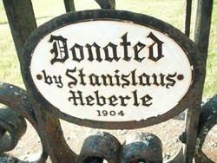
Added by: Ladygraver
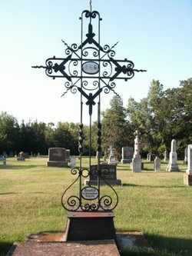
Added by: Ladygraver
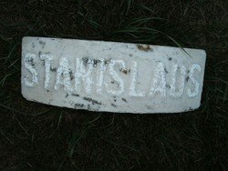
Added by: Ladygraver

